Complaining on Behalf of Someone Else
We keep to the strict rules of medical and personal confidentiality. If you want to make a complaint but you are not the patient, we will need written consent from the patient. This confirms that they are unhappy with their care and agree for us to discuss it with you. In the event the patient is deceased, then we may respond to a close family member, or someone involved in their care or wellbeing.
Please ask at reception for the Complaints Form, or we can send one to you after we receive your initial written complaint. This form includes a section for the patient to sign and give consent. If the patient is unable to give consent, due to illness, injury, or mental capacity. Please explain the situation clearly in your letter.
We cannot share any personal information or discuss someone else’s care without their written consent, unless one of the above situations applies. If you are making a complaint on behalf of a child who can speak for themselves, we may ask them to contact us directly. Depending on the type of consent we receive, we may still need to contact the patient directly or may be able to work with you instead.

If you are Dissatisfied with the Outcome
If you are ultimately not happy with how I have dealt with your complaint and would like to take the matter further, you can contact the Parliamentary and Health Service Ombudsman who make final decisions on unresolved complaints about the NHS in England. It is an independent service which is free for everyone to use. To take your complaint to the Ombudsman either visit http://www.ombudsman.org.uk/make-a-complaint or write to the Parliamentary Health Service Ombudsman, Citygate, Mosley Street, Manchester M2 3HQ you can also call 0345 015 4033

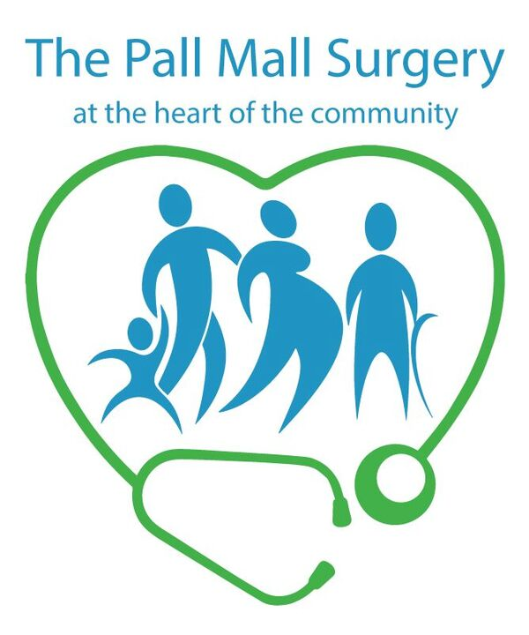

Complaints Procedure

Also see separate
Complaints Form,
available at Reception.
Policy & Procedure available on our Practice Website.

Making a Complaint
Most problems can be sorted out quickly by speaking with the person involved, often at the time it happens, and this may be the approach you try first.
If you cannot resolve the issue this way and want to make a formal complaint, please do so in writing as soon as you can—ideally within a few days. Try to include as much detail as possible, as this helps us understand what happened. Complaints should be made:
- Within 12 months of the incident, or
- Within 12 months of when you first became aware of the issue.
If you are a registered patient, you can complain about your own care. You are not normally able to complain about someone else’s treatment without their written authority. Please see the section about complaints on behalf of others for more details.
We have a Complaints Form you can use, which includes a section for third-party consent if needed. Ask for this at reception. You can provide this in your own format providing it covers all the necessary aspects.
Send your written complaint to:
The Operations Manager, The Pall Mall Surgery, 918 London Road, Leigh on Sea, SS9 3NG. You may also make your complaint directly to Mid and South Essex who commission our service:
Telephone 01268 594444
Email Mseicb.complaints@nhs.net

What We Do Next
We aim to settle complaints as soon as possible.
We will usually acknowledge your complaint within three working days and let you know how long it may take to investigate the matter. You will receive a formal written response, or you may be invited to meet with the people involved to attempt to resolve the issue. If it takes longer than expected, we will keep you updated.
When looking into a complaint, we aim to understand what happened, why it happened, and what we can learn from it. If you would like to talk to those involved, we can help arrange that.
When the investigations are complete, a final written response will be sent to you.
The final response letter will explain the outcome of your complaint and tell you how to contact the Parliamentary and Health Service Ombudsman (details shown elsewhere in this leaflet) if you are not satisfied with the response.
The Practice Complaints Manager is:
Mr Ryan Hills
Who is supported by the GP Partners at the Practice.
Dr Garcia, Dr Syed, Dr Evans – Smith, Dr McKay, Dr Noble and Dr Kebreya

If you would like any independent support in pursuing your complaint you are entitled to seek free assistance from the NHS Complaints Advocacy Service, who can be contacted on the following number – 01702 340566.

